**PoLyEOS**

*MANUAL (version 08.14.2018)*

Fei Wang, and Steven D. Jacobsen

Department of Earth and Planetary Sciences, Northwestern University, Evanston IL, 60202

**Overview**

PoLyEOS is a program for calculating and displaying the uncertainties in the calculated seismic velocities in a single mineral. The user enters the ambient thermoelastic properties of the mineral and calculates the seismic velocities at the temperatures and pressures inside the Earth, and then examines the influence of the measurement error in the input data on the seismic velocities and density. If the user does not have the bulk and shear moduli, the program can first calculate these from the elasticity tensor. The user chooses an equation of state (EOS), inputs thermodynamics data for the mineral, and specifies the depth, pressure and temperature in the Earth for which the seismic velocities are required. The output of PoLyEOS is Vp, Vs and density, which are shown in a Table and can be plotted as a figure. PoLyEOS is a visualization tool for understanding the error propagated to the seismic velocities from the uncertainties in the thermodynamics data and EOS used. All data/output can be exported for producing customized graphs.

**Installation**

PoLyEOS is a Python script with the following dependencies:

Python version 3.5 or higher :: PyQt5 or PyQt4:: matplotlib :: numpy :: scipy :: uncertainties.

The program is available for download from GitHub. To launch the program, run Main.py.

**Usage**

Executing Main.py brings up the screen shown as Figure 1.

The run consists of going through a series of steps, which are:

1. Enter the elasticity tensor (not needed if the user already has the bulk and shear moduli).
2. Select an EOS and enter thermodynamics data (the example here uses forsterite).
3. Enter depth, pressure and temperature at which calculated results are wanted.
4. Run the program.

There is no necessary order for steps 1 to 3.

***1. Entering the elasticity tensor***

The elasticity tensor calculator is a subprogram that can also be separately downloaded from GitHub. The calculation equation is from de Jong, M. (2015). The uncertainty (propagation of error) calculation is from Uncertainties: a Python package for calculations with uncertainties, Eric O. Lebigot, <http://pythonhosted.org/uncertainties/>.

This is not needed if the user already has the bulk and shear moduli. Otherwise, input the elasticity tensor into the “Convert elasticity tensor to averaged moduli” window at the top left, which calculates the bulk and shear moduli with the “Calculate” button. A pop-up window shows the result. The user chooses one from three sets of results from slightly different methods, and enter that into the “Set equation of state and thermodynamics data” window.

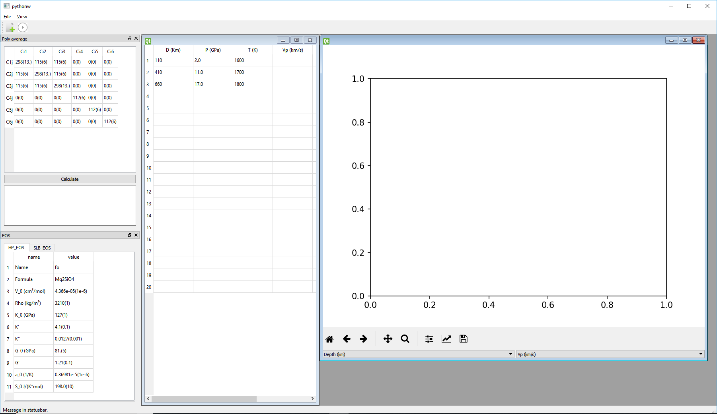Figure 1. GUI of PoLyEOS. This window appears when the program is launched.

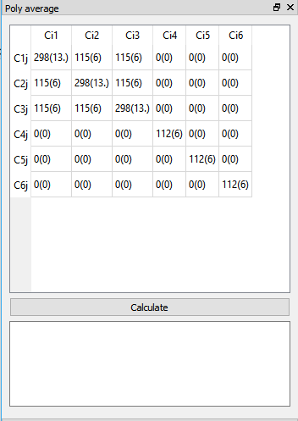

Figure 2. The “Convert elasticity tensor to averaged moduli” window at the top left calculates the bulk and shear moduli. A pop-up window shows the result. The user chooses the result to enter into the “Set equation of state and thermodynamics data” window.

***2. Entering thermodynamics data***

The user chooses the EOS that will be used to extrapolate the input ambient elasticity properties to the pressures and temperatures specified by the user in the Table on the right. The choices are: (1) SLB is the EOS developed by Stixrude and Lithgow-Berthelloni (2005), (2) HP is the EOS developed by Holland and Powell (2011). The choice is made in the “Set equation of state and thermodynamics data” window at the bottom left, where the user enters the thermodynamics data and measurement error. The format for a value can be “0.8(0.1)”, “ 1.3 (0.1)”, “ (4.366e-05(1e-6)”, etc. Note: The second number inside the parentheses is the absolute error. For example, 0.8(1) would mean that the error is 1.0, and not 0.1.

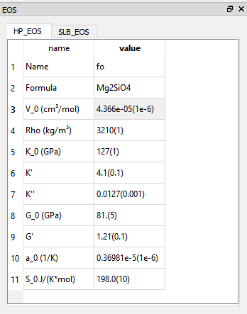

Figure 3. EOS window used to enter thermodynamics data.

***4. Running the program.***

The program is run by “File.run” from the drop-down menu. Alternatively for users with PyQt5, the run icon can be used. The program will show the results in the Table in the “Set depth parameters” window on the right and also as a plot of one of the results on the pop-up figure canvas. The button of the figure canvas lets the user choose which of the results to plot.

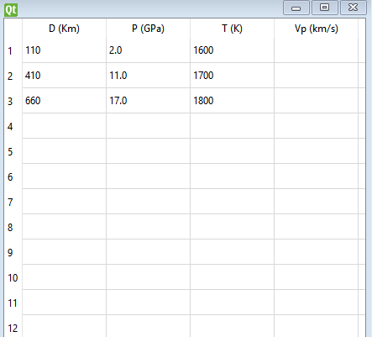

Figure 4. “Set depth parameters” window used to enter the depth, pressure and temperature at which results are wanted. The V*p*, V*s* and density results are shown in the columns on the right when the calculation is completed.

**Test run of the uncertainties:**

The program was verified by calculations that used the Monte Carlo (MC) method to calculate results to compare with the error propagation calculated by the program The comparison was made using the different EOSs made available in the program. Several pressures and temperatures inside the Earth and forsterite as the mineral were the selected points, and for each point, the MC calculation used 100,000 samples drawn assuming that all the parameters have a normal distribution. Figure 5 shows the result, which verified that the program using error propagation theory gives similar results as the use of the MC method and normal distributions. The small closed circles are the calculated values and the error bars show the estimated uncertainty calculated by the two different calculation methods.

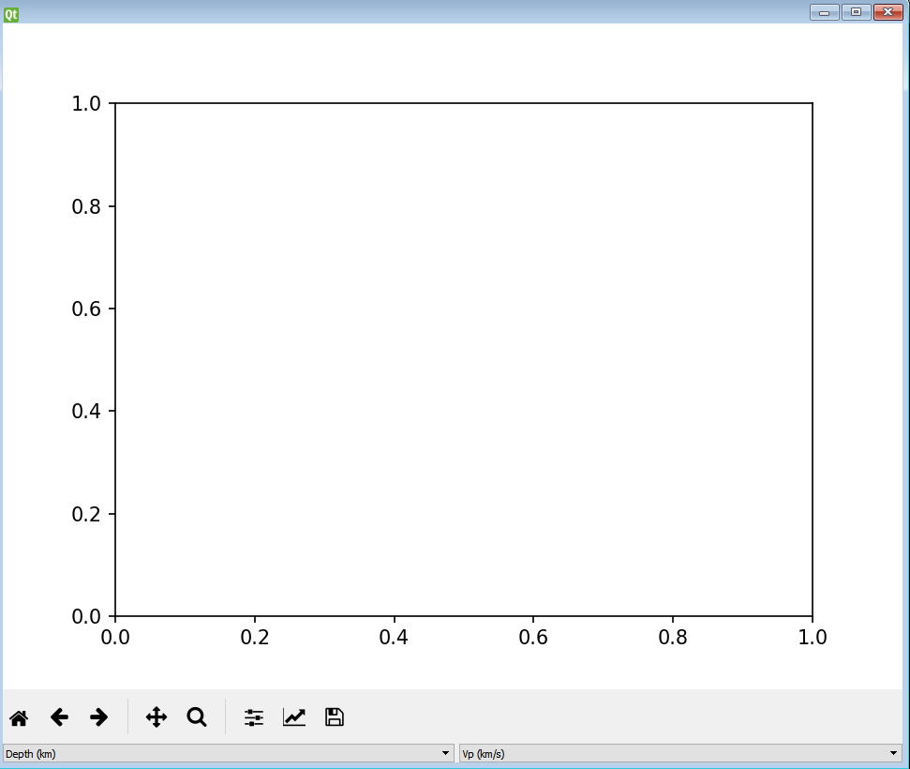

Figure 5. Figure canvas that shows the result.

A picture containing screenshot

Description generated with very high confidenceA screenshot of a cell phone

Description generated with high confidence

Figure 6. Comparison of error bars calculated by PoLyEOS and the Monte Carlo method.

Reference:

de Jong M, Chen W, Angsten T, Jain A, Notestine R, Gamst A, Sluiter M, Ande CK, van der Zwaag S, Plata JJ, Toher C, Curtarolo S, Ceder G, Persson KA, Asta M (2015). Charting the complete elastic properties of inorganic crystalline compounds. Scientific Data 2: 150009.

Holland, T. J. B., and S. A. T. Redfern. "Unit cell refinement from powder diffraction data: the use of regression diagnostics." *Mineralogical Magazine* 61.1 (1997): 65-77.

Stixrude, Lars, and Carolina Lithgow-Bertelloni. "Thermodynamics of mantle minerals—I. Physical properties." *Geophysical Journal International* 162.2 (2005): 610-632.